Steps 1-3

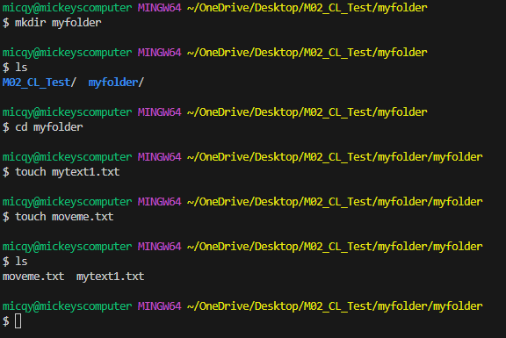

Step 4

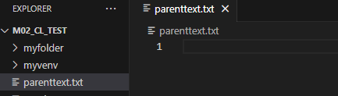

Step 5

